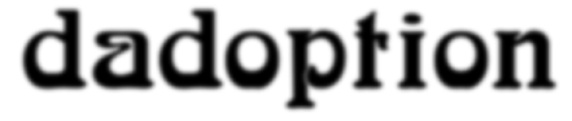

dadoption is a group exhibition in the form of a collaborative collage stretching over four 20 x 10ft billboards on a busy street in Liverpool City Centre.

dadoption evolved from four months of image dialogues between artists, citizens and creative workers with fatherhood, football and adoption on their minds. dadoption was produced by Liverpool-based artist Alan Dunn in collaboration with Russian artist Dmitry Gutov (Documenta 12, 2007), Israeli artist Guy Ben-Ner (Venice Biennale 2005, Skulptur Projekt Münster 2007) Arnold Böcklin (1827-1901), Cristian Roldan, Rafael Alvez, Leah Alconcel, Heidi & Zak and Glasgow-based painter Alex Dempster.
Venue: Billboards 1-4, Leece Street, Liverpool (opposite St Lukes Church)
Dates: Wednesday 10th October – Tuesday 23rd October 2007
Notes on artists’ contributions

In the photographic series Mam, Dad & The Champions League (2002), artist Dmitry Gutov dresses his mum and dad in football kits and invites them to play with a suspended ball in the bleak Russian landscape, away from crowds, rules and conventions.

In a still frame from Israeli artist Guy Ben-Ner’s Wild Boy video (2004), the artist and his son stand precariously at the top of a ramp, dressed alike in the fantasy of bringing somebody up after one’s own image.

Glasgow-based artist Alex Dempster has worked with Alan Dunn on billboard projects since they collaborated with writer James Kelman on a posterwork in 1990. His delicate but aggressive watercolour SWEET (2006) is presented here, digitally enlarged to five times its original size.

dadoption also explores issues such as the Madonna and Child images stemming from the popstar’s Malawi adoption, Shaun Wright-Phillips and Superman as adoption role models and a trio of remarkable footballing births (including Juan Román Riquelme and Luis Garcia) that took place on the eve of the 1978 World Cup Final, with Cristian Roldan, Rafael Alvez and Leah Alconcel in Buenos Aires, São Paulo, and London contributing their flickr images to this section.

Holding the collage together are two portfolios of images. Firstly, a series of childrens’ drawings and scribbles produced when angry and upset, counteracting the normally sunny images associated with young art placed in public settings and secondly details from the work of symbolist painter Arnold Böcklin, particularly those works housed in Basel Kunstmuseum.

Notes on organiser

dadoption forms part of the work of 67projects, a non-for-profit commissioning body chaired by Liverpool-based artist Alan Dunn. Born in Glasgow in 1967, Dunn studied at Glasgow School of Art and The Art Institute of Chicago and since 1987 has been commissioning and presenting new artworks on billboards including major new works by Robert Pollard (Guided by Voices), Scanner, Douglas Gordon, Pavel Büchler, David Jacques, Fiona Banner, Leila Romaya & Paul McCann and Bill Drummond.

Between 2001-7 he was lead artist with FACT on the ground-breaking community webcast project tenantspin, developing collaborative content with Pete Wylie, Alex Cox, Rirkrit Tiravanija, EAST05 & Gustav Metzger, Mike McCartney, BBC Radio 3, Chris Bernard, Kelly Mark, Dean Sullivan & Granada TV, Kim Ryan, the Communist Party of Liverpool, Will Self, Chris Watson, Hillsborough Justice Campaign, Jeff Young and Foreign Investment. In 2007 he co-authored and curated the landmark tenantspin Bold Street Project, attracting record audiences to the FACT Centre Media Lounge.

In early 2008 he will release a new compilation of commissioned audio works entitled Soundtrack For A Mersey Tunnel, developed in collaboration with Mersey Tunnels and musicians from around the world producing 2’33” long tracks to be given away free to tunnel users.

Contact details

Alan Dunn
Email: alandunn67@hotmail.com
Mobile: 07909 838 842
www.alandunn67.co.uk

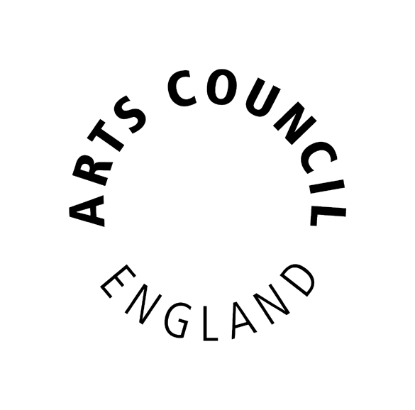Supported by Arts Council of England

